Weekly Report:

This week was introducing and making ourselves familiar with a variety of tools that programmers use as well as the various materials for our course.

I was familiar with using Terminal (on my Mac) and with using a file transfer client as I use those tools for work and hobby projects. I was not familiar with compiling in the Terminal since I usually use an IDE and can run programs from there. I have heard using Vim well is a good skill to have as a programmer, so I'm biting the bullet, so to speak.

The following is a visual representation of the tools we've used thus far.

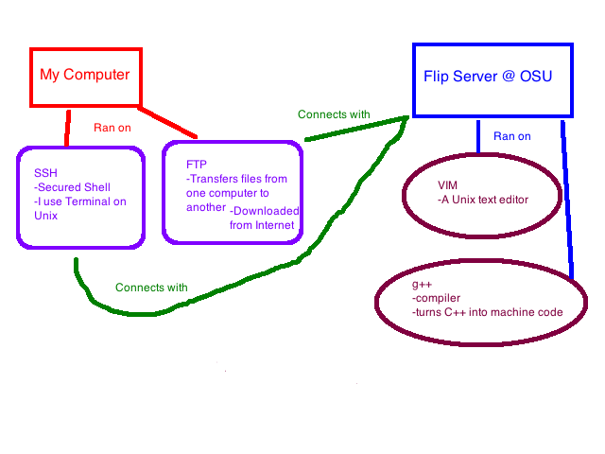

I needed to learn the specific language aspects of C++. Coming from Python, C++ has a lot more syntax. I've always been intimidated by C++ and it has not been quite such a bad beast so far.

Design for hello.cpp:

First the design for hello.cpp, a program that prints out “Hello world!”

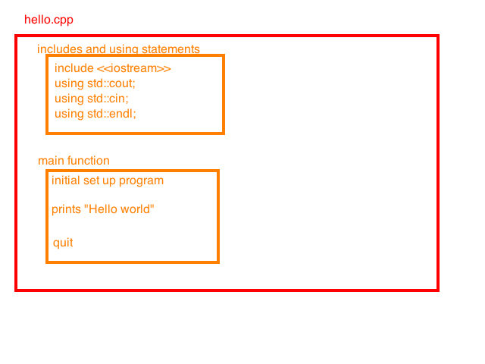

This is the basic idea, which looks like this:
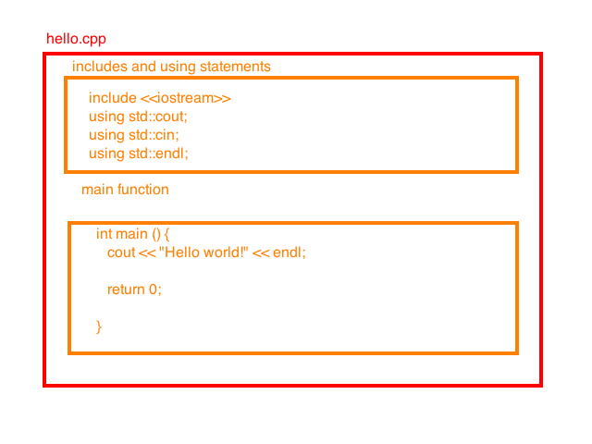

Testing:
There was not much testing of this file, as it simply prints out a string when executed. If the file did not work, I would suspect a typo. The majority of my errors so far have been typos, extra spaces, or not putting a space where there needed to be one.

Reflection:
This was my first C++ program. I felt good after running it and it actually worked. It took a while to get into the swing of things with vim (such as no backspace/delete button...the horror!) but it worked fairly smoothly. I understood why we were writing all of the code, even if I know that I don't understand all the implications of what we're doing.

Design for echo.cpp

Here is the basic idea for our echo.cpp, a program that asks for a user to input a number and then the program repeats, or echos, that number back to them.

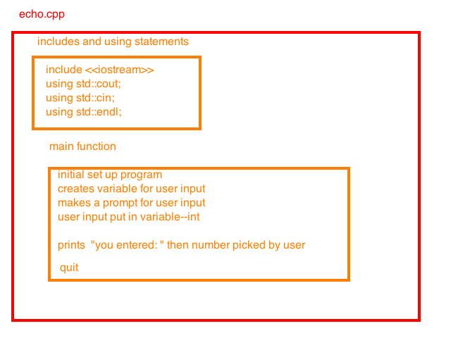

This program was fairly straightforward as we had done exercises similar to this program previously.

Testing echo.cpp

This program did require more testing. First, I had trouble running the program in the flip server, as I didn't know that g++ echo.cpp -o echo followed by echo would not work. It turns out “echo” is a command in flip and that command took precedence over my purposes. So, after using a.out instead, the program worked fine. First I tried using an integer, as I had coded for. This worked well. I then tried typing in a word. The program is not able to deal with this, so it gave back an answer “0”. This is expected behavior in C++.

Reflection:

This program was very similar to hello.cpp in its basic set up, but I did feel challenged by a few things. The prompts were similar to a practice question from the book, so I played around a bit more with having endl instead of line breaks that the book seems fond of. There is a lot more I could see this program doing (such as giving an error to the user when a non-integer is entered) but as that was not the assignment, I held myself back a bit. I learned more about testing, got frustrated with vim some more (such a high learning curve!!) but I feel confidant and ready for the next program.

